Heritage Weekend 8th and 9th September
Bell Ringing –
‘Demo’s’ and ‘Have a go’
will take place on the Castle Lawns
from 10am to 4pm Saturday and Sunday

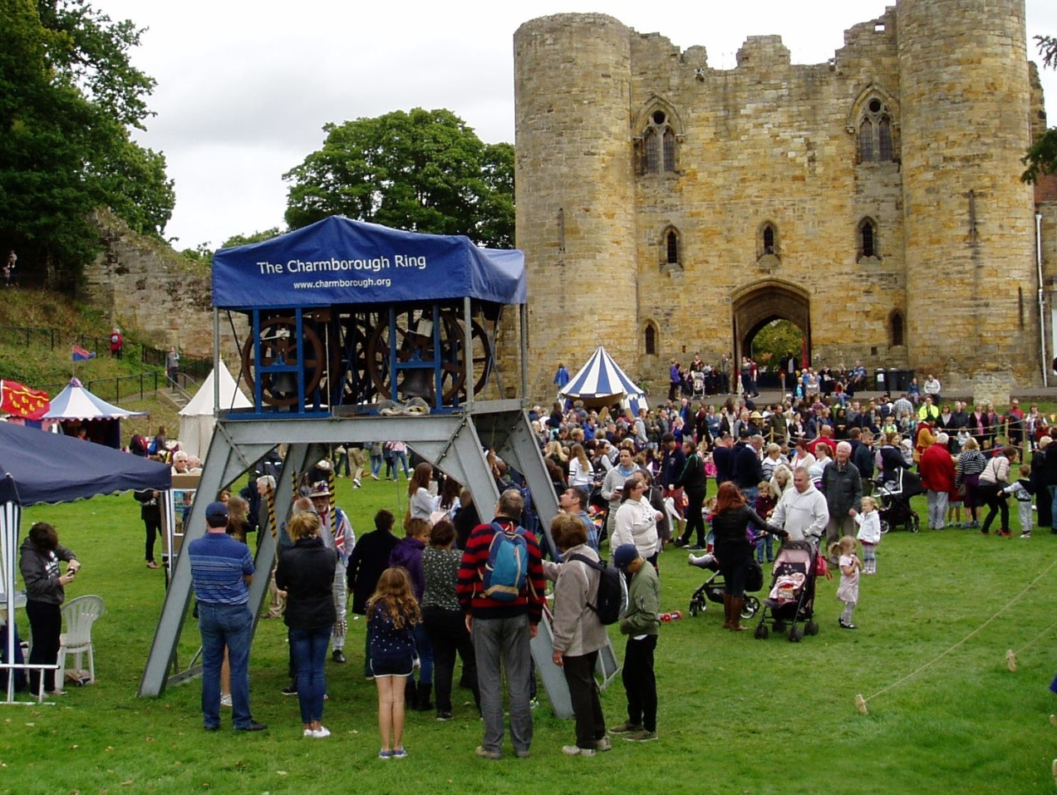

St Peters and St Pauls Bell Ringers ringing the Charmborough ring last year

For further details email Gavin at gavinspost@gmail.com

